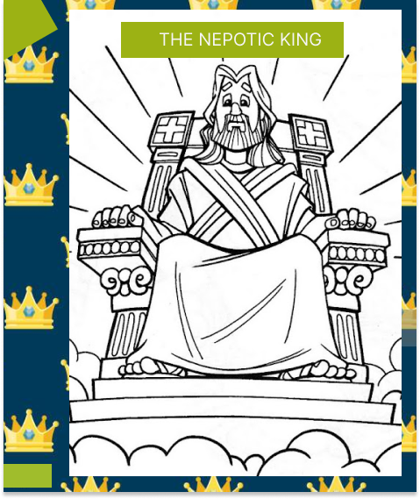

The Nepotic king is a short story written by Akansasira Isaac aka Omega. His first story was sacrifice for joy. Omega is a Ugandan from Kigezi in a village called Bugongi. He went to Bugongi primary school, Kigezi high school,st.micheal sonde and he is now at Uganda Christian University, MUKONO. The nepotic king is a short story about nepotism, its origin. This story is based on the kingdom of heaven.

To me nepotism should be judged fairly on the judgment day. This is the day when God will come on earth to judge the living and the dead, according to the Bible. We have seen nepotism in many ways, in leadership, education, business and more. Nepotism is a natural thing that happens in every field, so it is hard for one to avoid nepotism. Some people praise nepotism, they are in good fields and positions because of nepotism, guess where they would be if it was not their relatives…… Many towns are built on nepotism. To me the people who practice nepotism are right…….. because nepotism is part of work, when in doubt, you bring in relatives.

I have ever wondered why the world is full of nepotism. One Saturday I was reading the bible and realized that nepotism came from Heaven,that makes me recall one proverb “like father like son”. A son does things that were done by his father in childhood, if your father was a drunkard, then there must be one son in the family, who will inherit that habit. We as the children of God inherited the habit of nepotism from God ,our father who is in heaven.

Don’t judge me please, just think about it, why do you think I say that? Just imagine, God is sited in the kingdom of heaven, on his right hand there is his beloved son Jesus Christ, on his left hand there is Mary, the mother of Jesus, below Mary and her son, there are angels, below the Angels, there is Abraham (our Grand father), below him, there lies the apostles, also known as disciples. Why do you think on his right hand there is Jesus christ , his son? Even Abraham can fit in that position too…. Any disciple can also fit in that position too!,but just because of nepotism, everything there. Therefore no one can resist because it’s a habit from our father who is in heaven. That is why in the government presidents end up employing relatives and friends. To me , nepotism will always exist in school, hospitals, governments, and even families.

